BÁO CÁO THỰC HÀNH LAP 1

# The Very First Java Programs

## *2.2.1* Write, compile the first Java application:

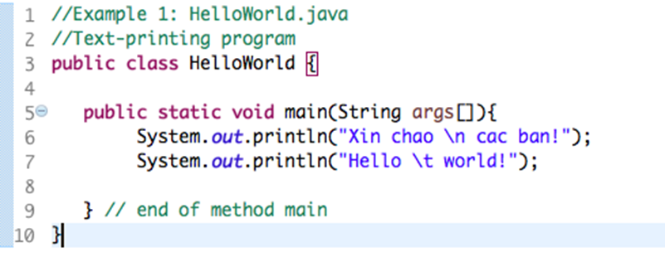

*Kết quả*

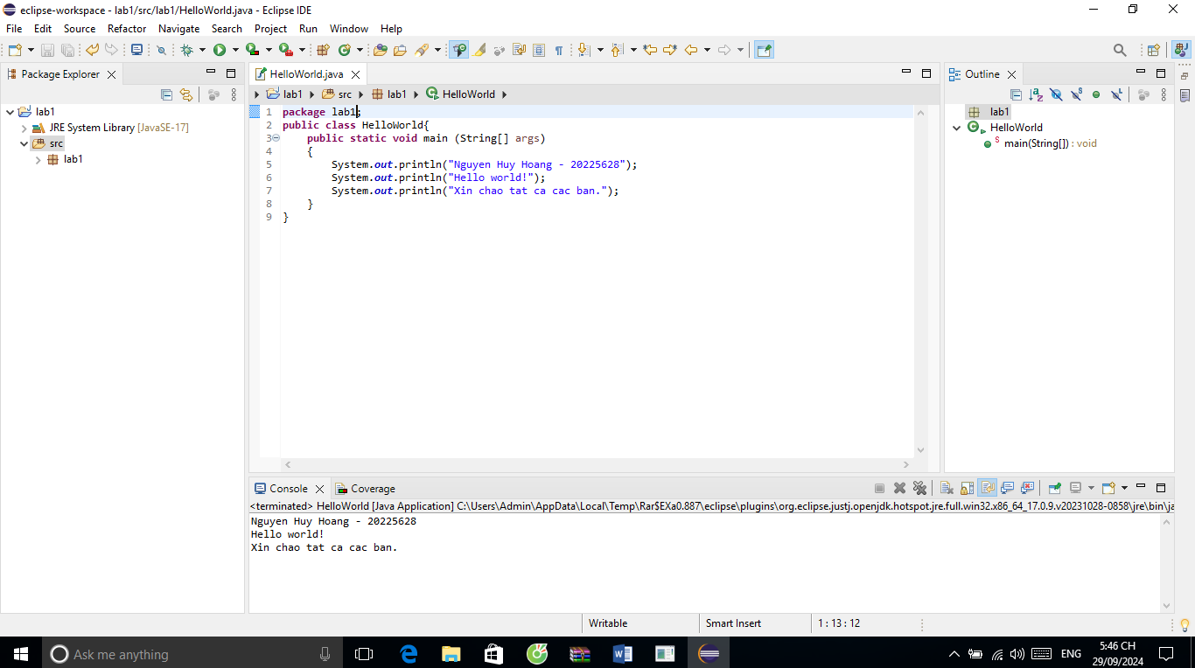

## 2.2.2 Write, compile the first dialog Java program

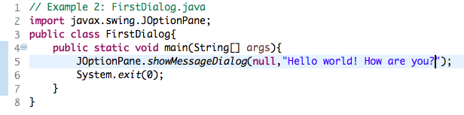

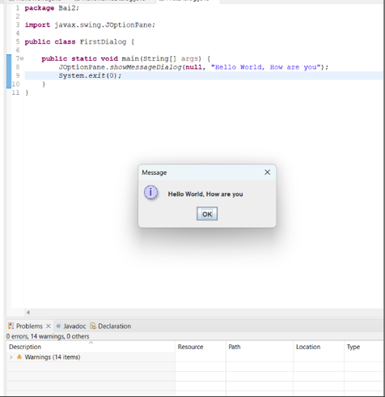

## 2.2.3 Write, compile the first input dialog Java application

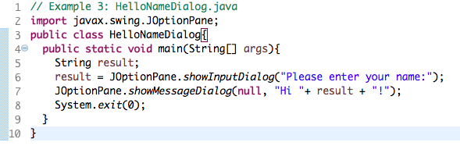

Kết quả chạy được như sau

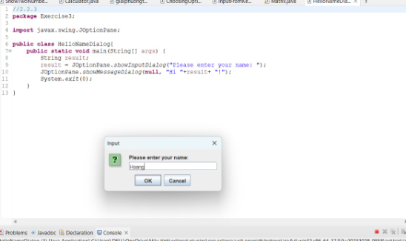

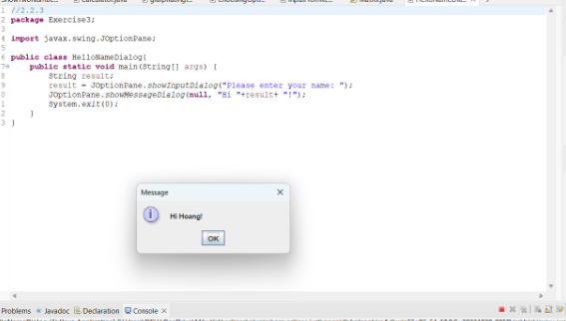

## 2.2.4 Write, compile, and run the following example:

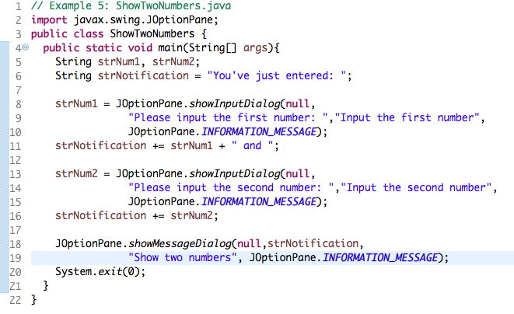

# BÀI TẬP

## 2.2.5 Write a program to calculate sum, difference, product, and quotient of 2 double numbers which are entered by users.

**Notes**

* To convert from String to double, you can use

**double num1 = Double.parseDouble(strNum1)**

* Check the divisor of the division
  + 1. ….

Ta có kết quả như sau

2.2.6 Write a program to solve: For simplicity, we only consider the real roots of the equations in this task.

Ta có chương trình và kết quả chạy

Kết quả chạy

6.1 Write, compile and run the ChoosingOption program

Ta có chương trình và kết quả chạy

6.2 Write a program for input/output from keyboard

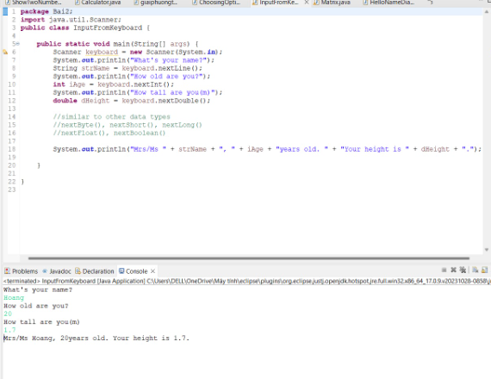

6.3 Write a program to display a triangle with a height of n stars (*), n is entered by users.

Ta có chương trình và kết quả chạy

6.4 Write a program to display the number of days of a month, which is entered by users (both month and year). If it is an invalid month/year, ask the user to enter again.

Ta có chương trình và kết quả chạy

6.5 Write a Java program to sort a numeric array, and calculate the sum and average value of array elements.

Ta có chương trình và kết quả chạy

6.6 Write a Java program to add two matrices of the same size.

Ta có chương trình và kết quả chạy như sau

Kết quả chạy

